**LAB 8**

**VARIANT 7,PI**

**TASK 1**

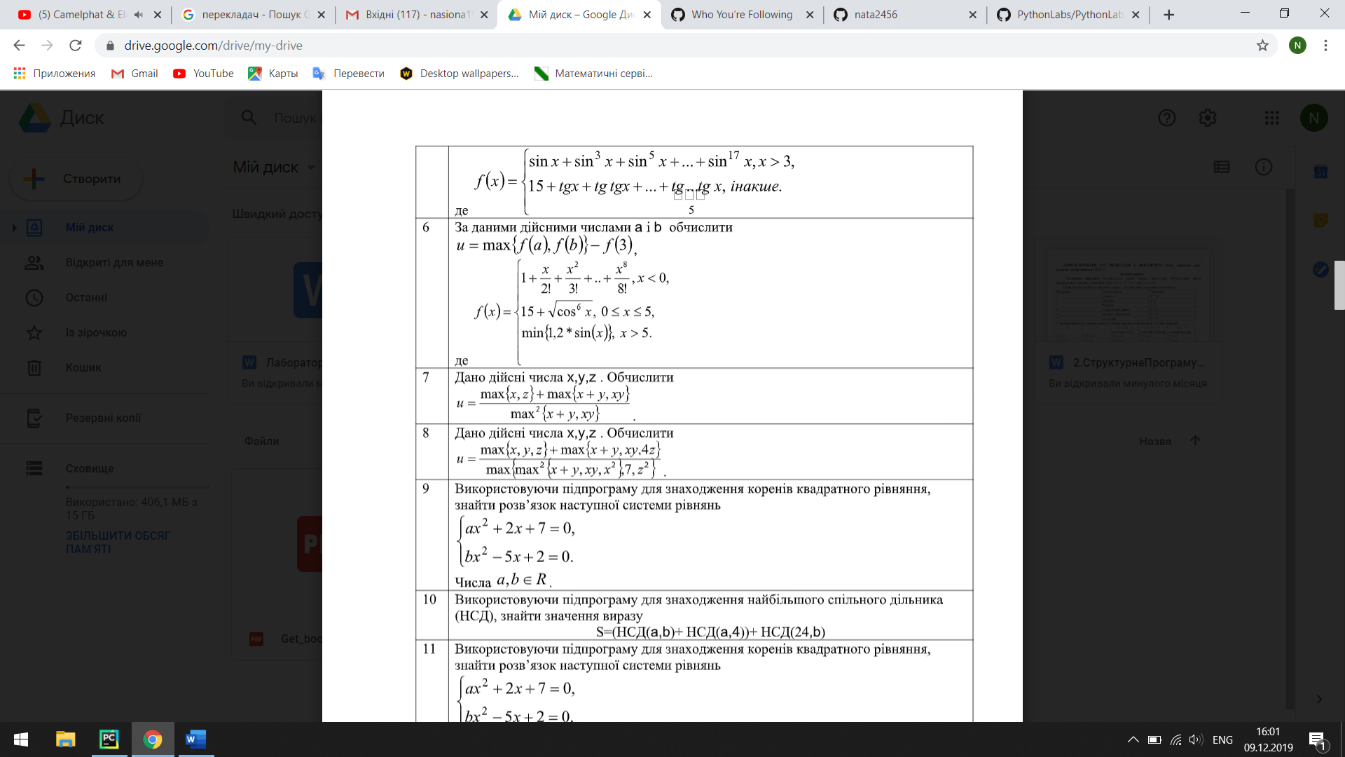

x=float(input("x="))  
y=float(input("y="))  
z=float(input("z="))  
print(max(x,y,z))  
print(max(x+y,x*y))  
print(max(x+y,x*y))  
u=max(x,z)+max(x+y,x*y)/max(x+y,x*y)**2  
print(u)

**or**

x=float(input("x="))  
y=float(input("y="))  
z=float(input("z="))  
def get_max(x,z):  
 if x>z:  
 return x  
 else:  
 return y  
sum=x+y  
dob=x*y  
def get_max(sum,dob):  
 if sum>dob:  
 return sum  
 else:  
 return dob  
u=max(x,z)+max(x+y,x*y)/max(x+y,x*y)**2  
print(u)

**TASK2**

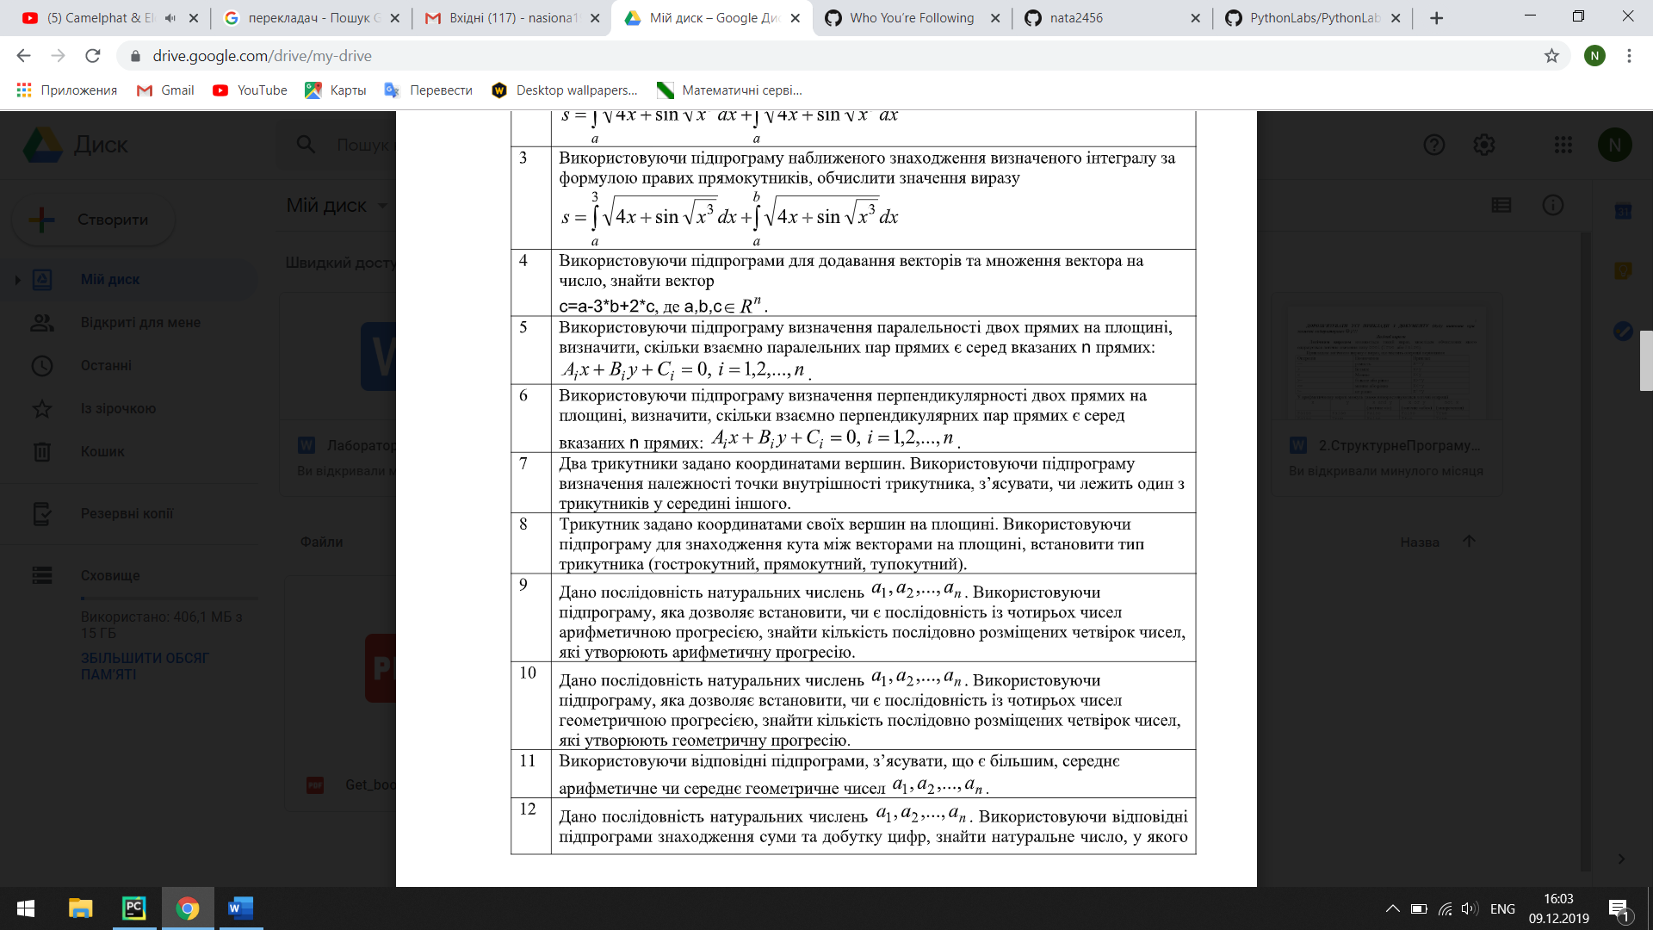

x_a=int(input("x_a="))  
y_a=int(input("y_a="))  
x_b=int(input("x_b="))  
y_b=int(input("y_b="))  
x_c=int(input("x_c="))  
y_c=int(input("y_c="))  
  
x_n=int(input("x_n="))  
y_n=int(input("y_n="))  
x_m=int(input("x_m="))  
y_m=int(input("y_m="))  
x_k=int(input("x_k="))  
y_k=int(input("y_k="))  
  
def triangle(x1,y1,x2,y2,x3,y3,a1,b1,a2,b2,a3,b3):  
 if x1<a1 and y1<b1 and x2<a2 and y2<b2 and x3<a3 and y3<b3:  
 return ("yes,these points belong to the triangle")  
 else:  
 return ("noo,it's false")  
print(triangle(x_a,y_a,x_b,y_b,x_c,y_c,x_n,y_n,x_m,y_m,x_k,y_k))

**TASK 3**

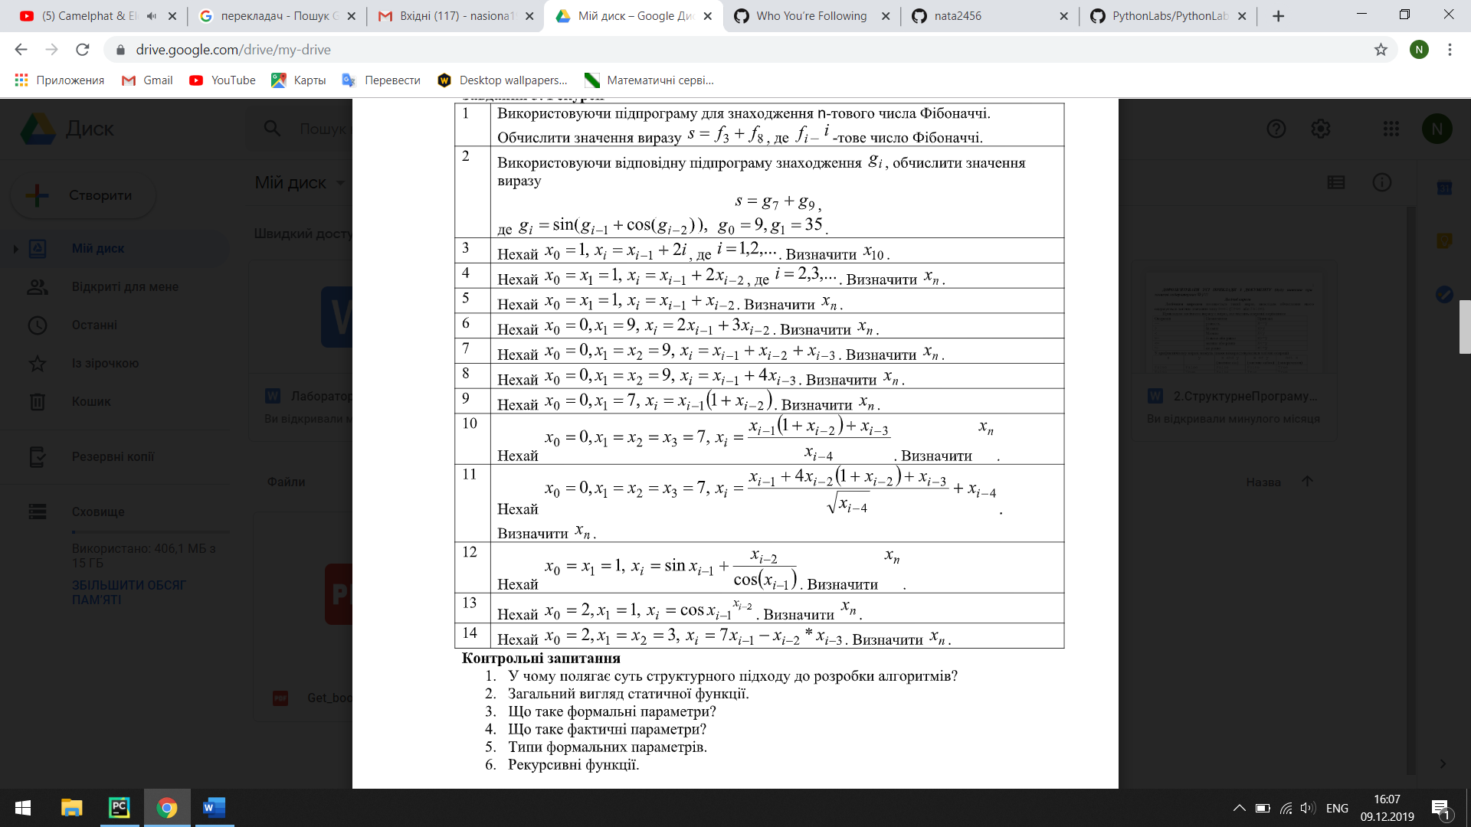

i = int(input("i="))  
  
  
def recurs(i):  
 if i == 0:  
 return 0  
 elif i == 1 or i == 2:  
 return 9  
 else:  
 return recurs(i - 1) + recurs(i - 2) + recurs(i - 3) \  
  
print("i({0})={1}".format(i, recurs(i)))